Autumn newsletter 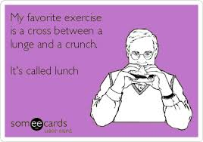

Welcome everybody to the Exercise club’s latest newsletter. With the arrival of the larger fish tank, and the burgeoning class timetable, you could be forgiven for assuming were getting Americanized and everything is getting bigger- so- I will try to keep this short and sweet.

Exercise Club party.
Hopefully you all have the date saved, as per Sue’s instruction. If not its
Friday 15th November 8pm start .
-there’ll be a small “awards” ceremony
-announcement of the results of “name the machine”
--and, rumour has it .....a band....!
Feel free to bring guests, too, if you like...

Yoga?
I’ve always wanted to offer yoga here, and a some of you will know, there has been a number of attempts over the years to do just that. Kelly Walsh, experienced yoga teacher and friend of a member, is hopefully going to make it work for us...
So; Thursday mornings, 10.30-11.30 is the possible timeslot..It’ll be £8 per session or £42 for 6 ( normal ticket system we use already for pyp and short circuit)
I need to know definite numbers before going ahead, so if you’re interested please show your hand by telling us at reception- we need 6 to get started, I’ve pencilled the first class in for 3rd October!!!

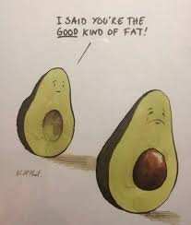

Feelfit Training, with Ellie
So we were approached by Ellie as a venue she would like to hold some classes at. There will be “functional fitness” on Mondays at 3pm,. And “Feelfit 4mums” at 9.15am Fridays.
I don’t know that much about Ellie yet, but what I do know id she’s full of life and fun, i suspect her classes may well be delivered in a different style to anything we currently offer....

PATT ( Parents And Teenagers Together); Short circuit..
This class is aimed at, but is not exclusively for, children from maybe 11 to 18 who perhaps haven’t found love within the school sports system, and their parents.
The exercises are non-competitive which is not the same as “easy”, its just that nobody wins or loses..
9.00-09.30 Saturdays.
1st session free
£3 or 10 tickets for £25
For more info call Ross 07587552653 or Ross@theexerciseclub.co.uk

Also, we have introduced another short circuit class at 10.00 am Thursday mornings.
Short circuit is a holistic approach to circuit training, incorporating balance, memory, co-ordination, aerobic and core strength work..
Its accessible for any age, any fitness level, so any of you guys and girls who fancy it , please com along!
Sometimes you’re the bug...and sometimes you’re the windscreen..
(ancient Hawaiian proverb)
1st session free
£3 or 10 tickets for £25

I feel at this point its important to check that we’re all paying proper attention to the words of one of our more seasoned members, Ralph Austerberry. Please fill in the blanks. Prize for the best effort (“best” not necessarily the same as “right”) In brackets are the number of letters in each word..

Once upon a(4) .......there were (3).......rabbits. Now there’s millions of the (7) ............

Don’t take any (7) ..............Nickels

There we were, upside (4).......... over(7).............., nothing on the (5)........but the maker’s name

There’s no point being a geriatric old (4) ........... if you can’t behave like one

I’m waiting for a (3).........there used to be a ....... (4) through here

(1)....dont wish to(4) ...........that, kindly leave the (11).............................

You’re doing a great(3)..........I’ll see you get promotion. Acting(6).............for the first 6 months

